Create Insurance Database



Create Insurance tables

1. Create Claims Table

1. Create Customer Table

1. Create Policy Detail Table

1. Create Reserves Table

Populate Insurance tables with sample data which you created in above step.

1. Claim Table Data

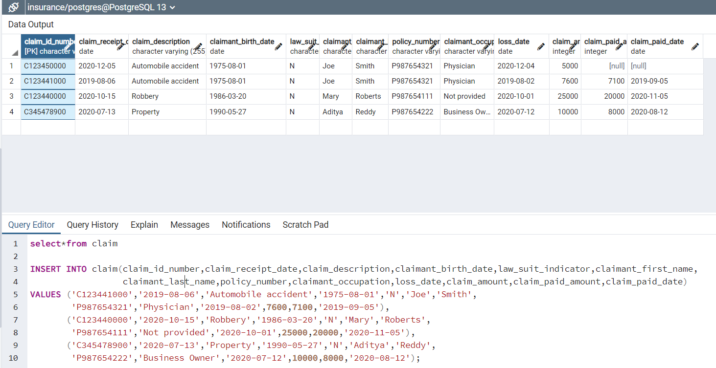

1. Customer Table Data

1. Policy Detail Table Data

1. Reserves Table Data

Form any 5 SQL to extract information from tables. Use Join, Where, Other conditional operators.

1. Inner join customer and policy_detail tables:

SELECT*FROM customer inner join policy_detail on customer.customer_id_number=policy_detail.customer_id_number

1. Full outer join claim and customer tables

SELECT*FROM claim full outer join customer on claim.claimant_first_name=customer.customer_first_name

1. Show customers whose risk score is over 50

SELECT * FROM customer

WHERE risk_score>50;

1. Show customers that have a reserved amount of 1500

SELECT customer_id_number,policy_number,reserved_date

FROM reserves

WHERE reserved_amount = 1500;

1. Update claim paid amount to 4000 in rows where the claim amount is 5000

UPDATE claim

SET claim_paid_amount = '4000'

WHERE claim_amount = '5000';

